
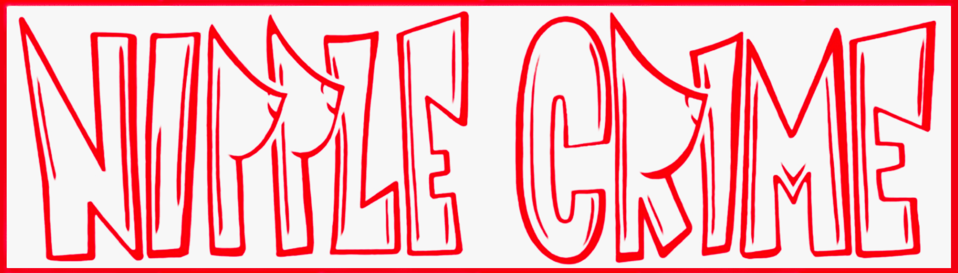

STANDARD OPERATING PROCEDURE
Slack

SOP Number | Com1 | Department | Communications
Version | 1.0 | Effective Date | 2026-03-03
Last Updated: 2026-03-03

1. Purpose
This SOP covers how Nipple Crime uses Slack as its central internal communications platform. It defines the channel structure, posting rules, and the meeting recap process managed by the Communications Officer.

2. Channel Structure
- #announcements — Camp-wide announcements; replies in thread only
- #leadership-board — Board-level discussion (board members only)
- #leadership-general — All leadership roles
- #committee-food — Kitchen & Bar committee
- #committee-power — Power Grid team
- #committee-lnt — Leave No Trace team
- #help-wanted — Open asks and volunteer recruitment
Additional committee channels created as needed using the #committee- prefix.

3. Posting Rules
- Announcements: one top-level post, all replies in thread
- Decisions: summarize in one 'Decision:' message and pin it to the channel
- Pin the following in relevant channels at all times:
- Interest / labor form link
- Dues payment link (when available)
- Org chart
- Meeting recap index

4. Meeting Recap SOP
Owner: Communications Officer
Deadline: Post within 24 hours of any board or leadership meeting.
Post to: #leadership-board in Slack (and optionally email the board).

TEMPLATE (copy/paste each recap):

Meeting: Board Meeting -- YYYY-MM-DD
Attendees: [list names]

Key Decisions:
- Decision 1 (who decided, any constraints)
- Decision 2

Action Items (Owner | Action | Due Date | Dependencies):
- [Owner] -- [action] -- [due date] -- [dependencies]

Risks / Watch-outs:
- [Risk] -- [mitigation owner] -- [next check-in date]

Next Meeting:
- Date/time + what must be ready by then

5. Contacts
- Communications Officer (Slack owner): Daemon Wyner
- President (approves major messaging): Reece Dassinger
- VP / SOP Owner: Chris Reddin

6. Revision History
- v1.0 | 2026-03-03 | Initial draft | Chris Reddin

